Data in the table BRANDS.

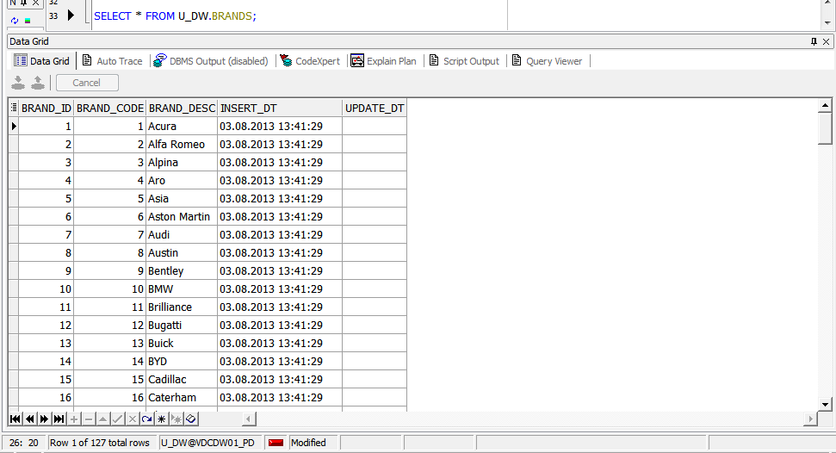

Data in the table MODELS.

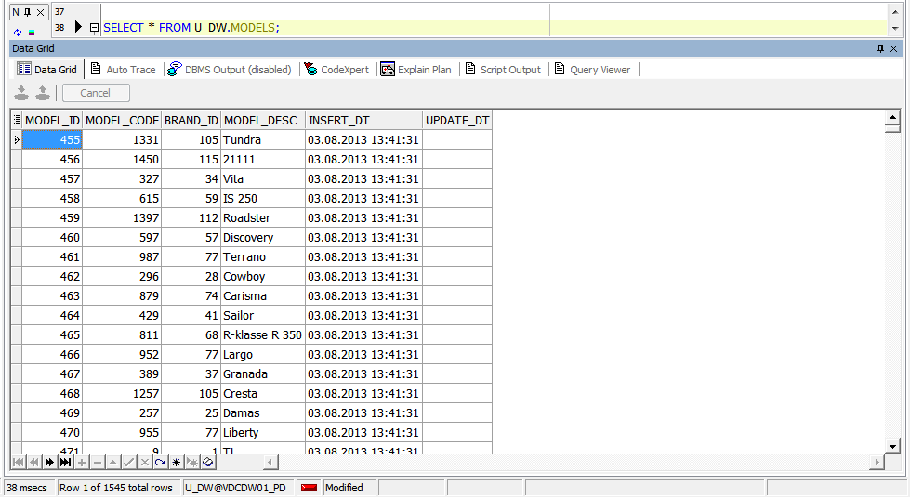

Data in the table CARS.

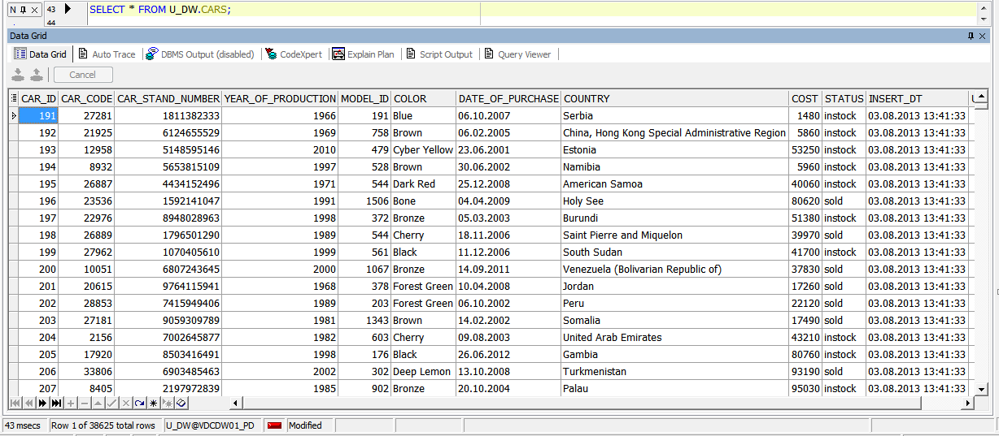

Data in the table CITIES.

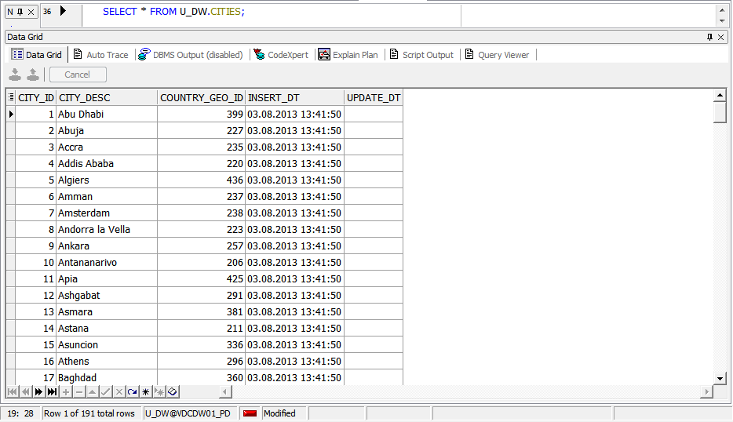

Test data for consistent.

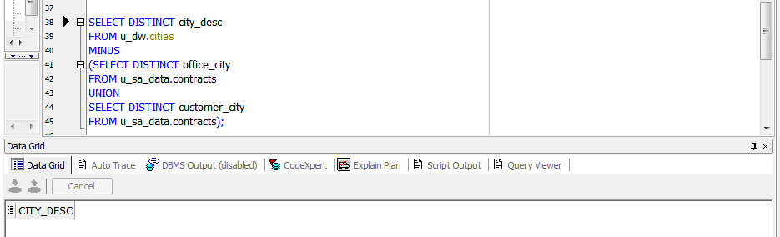

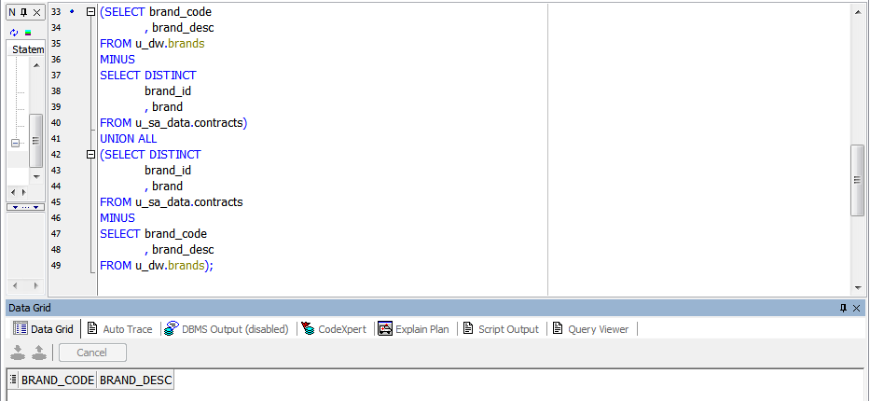

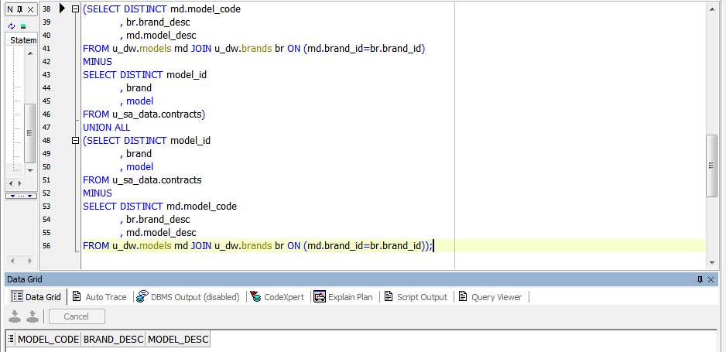

(SELECT DISTINCT cr.car_code

, cr.car_stand_number

, cr.year_of_production

, md.model_desc

, cr.color

, cr.date_of_purchase

, cr.country

, cr.cost

, cr.status

FROM u_dw.cars cr JOIN u_dw.models md ON (cr.model_id=md.model_id)

MINUS

SELECT DISTINCT car_id

, cat_stand_num

, year_of_production

, model

, color

, date_of_purchase

, country

, cost

, status

FROM u_sa_data.contracts)

UNION ALL

(SELECT DISTINCT car_id

, cat_stand_num

, year_of_production

, model

, color

, date_of_purchase

, country

, cost

, status

FROM u_sa_data.contracts

MINUS

SELECT DISTINCT cr.car_code

, cr.car_stand_number

, cr.year_of_production

, md.model_desc

, cr.color

, cr.date_of_purchase

, cr.country

, cr.cost

, cr.status

FROM u_dw.cars cr JOIN u_dw.models md ON (cr.model_id=md.model_id));

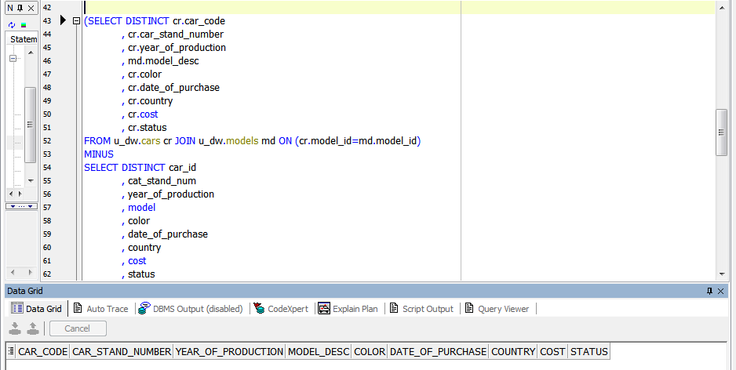

After repeated execution of the packages all tables in the U_DW scheme have not changed.